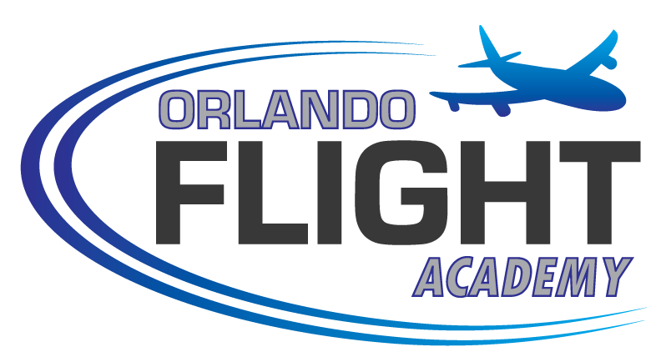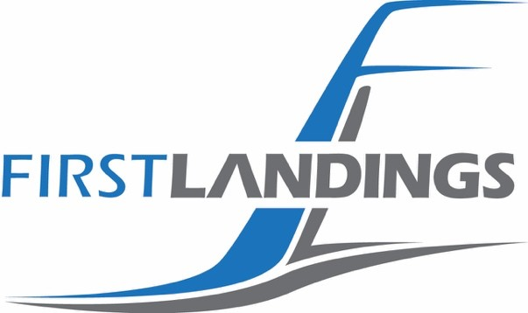

Student Visa Application Instructions

To begin the process of obtaining a Student Visa for flight training at First Landings Aviation (Orlando Flight Academy), each student must submit the following required information. The process is simple and requires that you do the following:

- Complete the Student Visa Application & Financial Affidavit Form - Simply download the Student Visa Application, print and provide the required information. Scan the pages to a file.

- Make a Digital Copy of your Passport - Scan your passport so that the page containing your photograph and the passport expiration date are clearly visible. Scan the copy to a file.

- Make a Digital Copy of your Bank Statement - Scan your proof of financial responsibility. This is proof that you have the funds to pay the entire cost of your training and living expenses while in the United States. This can be a copy of your bank statement with your name and sufficient available funds (NOTE that funds requirements will vary depending upon the selected flight program). Also acceptable is a letter from your bank indicating funds available equal to or greater than that required amount.

- Attach and Send - Create an email and attach the above three items to: info@FirstLandings.com

- Flight Schedule Pro – We will create a Flight Schedule Pro account in your name, and send you an invoice for the M-1 processing fee of US$450.00. This will also allow you to upload all of your associated documents.

- Pay the Non-Refundable Processing Fee on FSP by Credit Card

Once we have received and reviewed all three items attached to your email, we can begin the process of helping you obtain your M-1 Visa. We will send you a digital copy of the signed M-1 visa, and courier you the original.


1321 Apopka Airport Road, Unit FBO Apopka, FL 32712
+1 (407) 886-7612
www.flyofa.com

Orlando Flight Academy, Inc.
Student Visa Application & Financial Affidavit

Student Biographical Information
 | Family Name |  |  | First Name
 | Date of Birth  dd/MMM/yyyy | Gender  Male Female | City & Country of Birth |  | Country of Citizenship
Applicants Current Residential Address
Street Name and Number City Province / Sate Postal / Zip Code Country
 | Passport Country Issued by | Passport Number |  |  | Passport Expiration Date
 | Telephone Number |  | E-Mail Address
IN CASE OF EMERGENCY CONTACT Relationship:

Name: Phone:
STUDENTS PLEASE READ AND SIGN
I wish to gain admission to Orlando Flight Academy, Inc., and am registering for the Commercial Aviation Program. I certify that the above statements are correct and true.
 | Date |  | Signature

Enrollment@flyofa.com
Student Information

Proficient to Read | English Proficiency  Proficient to Write | Proficient to Speak | High School | Education | College or University
I certify that the amount of funds indicated in the bank certification section on this form, or in any submitted
financial statement or letter, are available for my academic study at Orlando Flight Academy, Inc. Additionally, I have sufficient funding to support myself throughout the expected duration of the Flight Training Program.
Student Signature:
Date:
Student Financial Certification
Self. Submit financial documents which list your name as the account holder.
Sponsors. Submit financial documents listing account holder(s) as your parents, spouse, or family.
Scholarship or Financial Award. Submit a copy of your award letter. Business or Government. Submit a copy of your award letter on letterhead. Other. Please indicate your source of funding.
Sponsor Financial Certification (Only required if student has sponsors).
Named account holder must sign and certify the Orlando Flight Academy, Inc.'s Financial Affidavit.
Sponsor Name:
Sponsor Signature:
Date:
Complete Application
E-Mail application to
info@FirstLandings.com
Legible, Digital Copy of Passport
Digital Copy of Bank Statement or Financal Certification Show Proof of Healthcare / Accident Insurance
Student Checklist

